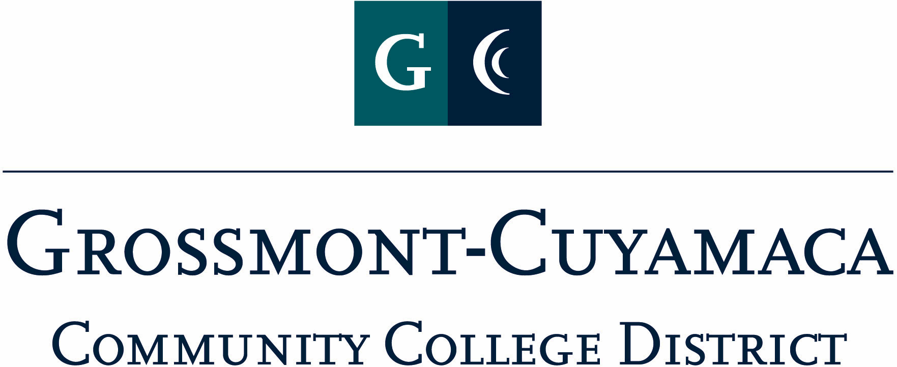
D R A F T
CLASSIFIED SENATE
EXECUTIVE BOARD MEETING
February 2, 2010

Members Present: Debi Miller, Paula Tillery, Avelina Wilder, Kimberly Gioscia, Wendy Corbin, Yvette Macy, Maria Briney, Scott Howell, Jacqueline Osborne, Pat Murray, Karen Ostegard,
Members Absent: Maggie Gonzales, Patricia Bailey, Monica Farris, Jean Wallace
Members Excused: Angela Johnson, Karen McCoy

1. Welcome and Call to Order

The meeting was called to order at 12:08p.

2. Approval of Minutes from December 3, 2009

The minutes from December 3, 2009 meeting were approved. M/S/A Pat Murray/Kimberly Gioscia.

3. Communication

VP Reports

District: Wendy Corbin wanted to thank all of those classified at the district who contributed to the Assist-A-Student Campaign, and special thanks to Angela Johnson for all her efforts. She added that she is working with her executive officers on their assignments for Classified Staff Appreciation Day, and wants to help determine the point of contact for certain responsibilities. Debi Miller commented that this is the first year that there has been a formal process written down to reference, and that if anyone has any concerns on what is involved to call her. She did add that most of the responsibilities are worked on at the Annual Organizational Meeting and the day of set up. As all the officers become familiar with what CSAD entails through their first-year experience, they will then be able to carry over their experiences for next year.

Grossmont: Pat Murray asked for clarification on how the restructuring is going at the district and if we will receive any recent notification of how it is working and if the classified can help out in some way. Paula Tillery referenced the memo from the Chancellor that went out in October outlining the restructuring of departments at the district. Jacqueline Osborne indicated that currently there is a “soft freeze” on positions, but the district is in the process of hiring a Director for Employment & Labor Relations. She added that the status quo had not changed since the memo. Wendy Corbin also mentioned that due to the recent retirements, and the “frozen” status of contractual position, efforts are being made to cross-train.

Pat reported that she was invited to introduce newly hired staff at Convocation, but since there were none hired in the fall it was not necessary, but she will be included on the agenda for the future whenever there is new hires to introduce. She also stated that prior to Convocation her and Patty Sparks wrote down the names of staff that attended. This year, the event included a power point being played in Griffin Gate, so people could come and go as they please, if they were not able to stay for the entire event. A member suggested that perhaps in the future a network presentation might be available to access at your desk, for those who are not able to attend, but have time to access on their computer. She informed the group of the upcoming move of the Administration Quad to trailers in the beginning of Summer.

She informed the group of the recent e-mail that went out inviting all classified to staff development activities on behalf of her and the Faculty Development Chairs.

During the two weeks prior to Professional Development Week, the exercise (gym) area was open to all employees to use. The college is considering doing this on a regular basis prior to the start of Professional Development Week.

Pat Murray informed the group of the recent meeting between the President and the VPs to discuss the foundational basics of Classified Staff Appreciation Day. The keynote speaker has been identified and give away gifts have been arranged.

She brought their attention to the handout on the Ethics Statement from Grossmont College and asked everyone to review and send her any feedback by 2/11 so she can bring to Leadership Council. The VPSS and VPAA will include this statement as part of the Strategic Plan.

Cuyamaca: No report.

President’s Report: Debi Miller reported on the following: (1) Chancellor/Classified Senate Award: reminder to get your scores in; (2) Classified Staff Appreciation Day (CSAD) Reference Guide: to let her know if there were any necessary edits, but to use it as a reference guide for the responsibilities you volunteered for; (3) Volunteer List from CSAD, the volunteers who are listed for set up will be sending an e-mail to schedule a meeting with Tim Flood to discuss the set up for the day involving facilities, operations, custodial and electricians; and (4) Leadership Meeting with the Chancellor generated an idea exchange about holding a Student Hourly Celebration spearheaded by Maggie Gonzales. It is still in discussion stages, and will be brought back at the next meeting.

Treasurer Report: Paula Tillery referenced the Treasurer’s Report and added that there is a $283 encumbrance that will be released relating to the See’s Candy Fundraiser. The President pointed out the grid at the bottom of the report that indicated the profits from this fundraiser.

4. Continuing Business

Tecate Children: Pat Murray shared that her experience with this donation. She tried to be a part of the day they were giving the gift, but rain and a muddy road prevented her from attending, and when they changed the date, she was unable to accommodate. She appreciated the Thank You and pictures received.

Assist-A-Student: JacQueline Osbourne reported on behalf of Angela Johnson. She said it was a fun experience and the VPSS office was kind enough to provide a heater to keep them warm as they sat at the table. She added that she worked side-by-side with Maria in student services. They ended up helping quite a few students. She would like the CS to plan on this event in the future. She distributed quite a few buttons.

C&Bs – 1st Read: The C&Bs were distributed as a handout for a 1st read by the group. Pat Murray directed them to send any corrections, etc. to her by 2/11. She explained that she highlighted any significant changes to the C&Bs so you could spot them. The review committee added the fiscal responsibility article in an effort to start the year with a budget, a plan for expenditure and start off the year anticipating what to do with the money.

5. Fundraising Activities:

See’s (for Spring): Yvette Macy explained that her and Paula Tillery will be coordinating this fundraiser. She expressed the need to get everyone involved with the fundraising efforts and to have order forms and a flyer at your desk and in the break rooms so the information is well communicated. She is working with See’s on a deadline date and will be sending out the order flyer shortly.

Cookbook: Karen Ostegard informed the group that she had talked to Holly in duplicating, and they would charge $2 to print the cook books. The anticipated cost to purchase would be $10. Pat Murray is working on an E-mail Announcement to be sent out with the contact people being herself, Karen and Maria. The e-mail will be sent to the entire district. The group discussed how many to order, an estimated amount would be 200. The cookbook will be rolled out at CSAD. Wendy Corbin asked that the fundraiser be tied to a specific purpose for the profits. The group exchanged ideas and they were recorded. Due to time restraints, the President will send out the scenarios by e-mail for a vote, and a majority will determine how the proceeds should be distributed.

6. Governance: Nothing to report.

7. New Business:

Annual Organization Meeting Date: Due to time restraints, the President will send out via e-mail for a vote, and a majority will decide the outcome.

Luncheon w/the Board: Due to time restraints, the President will send out via e-mail for a vote, and a majority will decide the outcome.

The meeting adjourned at 1:02p

